1. M.P.D.S.A (Na Salt)

<https://www.bluearkindustries.com/images/product/MPDSA-Sodium-Salt.jpg>

1. M.P.D.S.A (Acetyle)

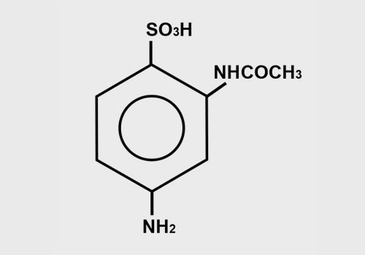

1. M.P.D.S.A (Free Acid)

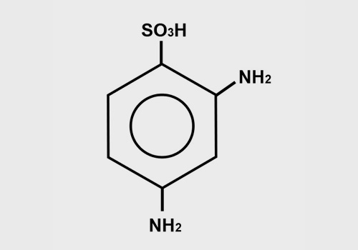

1. Aniline-2,5-DiSulfonic Acid

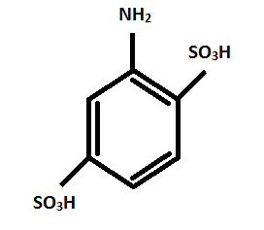

1. PARA NITRO TOLUENE ORTHO SULPHONIC ACID

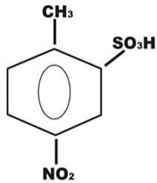

1. METANILIC ACID

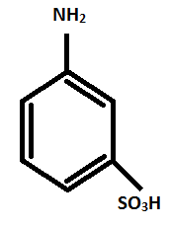

1. META UREIDO ANILINE

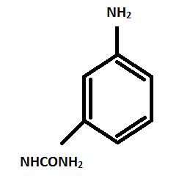

1. PA3SA

